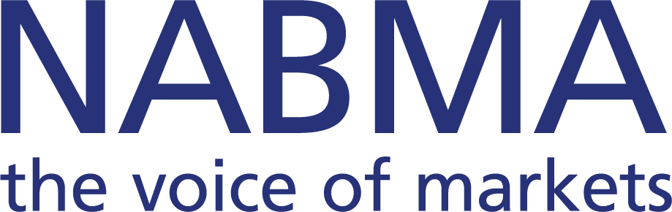

All-Party Parliamentary Local Markets Group
Minutes of a meeting of the All-Party Parliamentary Local Markets Group, held on Wednesday 21st January 2026 at 13:00 in Room R, Portcullis House

ATTENDANCE
Julia Buckley MP (Shrewsbury)
Rachel Gilmour MP (Tiverton and Minehead)
Steve Witherden MP (Montgomeryshire and Glyndŵr)
Sally Jameson MP (Doncaster Central)
Andrew Ranger MP (Wrexham)
Jo Platt MP (Leigh and Atherton)
Jodie Gosling MP (Nuneaton)
Ann Davies MP (Caerfyrddin)
Cllr Chris Poulter – NABMA President
Gary Jaques – NMTF President-Elect
Joe Harrison – Chief Executive NMTF
Tania Murphy – Member Support and Business Development Manager, NMTF
Allan Hartwell – Market Place Europe
David Catterall – Chief Executive NABMA
David Preston – NABMA Consultant

- WELCOME
A welcome was extended from Julia Buckley MP to the All-Party Parliamentary Local Markets Group. It was noted that the APPMG is a cross-party group within Westminster that provides a conduit for the local markets industry to Parliamentarians to advance the case for markets and to raise issues about their welfare. It also provides a forum for discussions about policy strategy and operational issues, recognizing the role and influence of markets and market trading in retail tourism employment, hospitality and leisure sectors. The lead organizations are NABMA and NMTF.

- MINUTES
Minutes of a meeting held on the 22nd October 2025 were confirmed and signed.

- ELECTION OF OFFICERS/AGM GOVERNANCE
In accordance with the rules for All-Party Parliamentary Groups the following were elected:
- Chair Julia Buckley MP
- Rt Hon Lord McLoughlin (Conservative) Vice Chairman
- Lord Goddard, Stockport (Liberal Democrat) Vice Chairman
- Ann Davies (Plaid Cymru) Vice Chairman

- FINANCIAL DECLARATION
It was RESOLVED to note that a nil return had been submitted in terms of the declaration required by parliament.
- AROUND THE MARKETS
The Members of Parliament outlined performance of their support for their local markets. These included Doncaster and Wrexham. Of interest was the fact that BID is the driver in many areas now for market regeneration and high streets. The question was also posed as to how government funding has been used to support local markets and local high streets. The NABMA Chief Executive offered to provide an update on this matter for a future meeting.
- UPDATE FOR THE HOUSE OF COMMONS TERRACE RECEPTION - 5th MAY
The respective Chief Executives of NABMA and NMTF updated on the progress of the event which is being organised by NABMA. The event to profile Love Your Local Market and the National Young Traders Market, also promoting the many benefits of markets and the opportunity for start-up businesses and young entrepreneurship. The event to be a celebration of community, creativity and commerce. The Chairman was hoping to ensure that both Houses in Westminster buy into the event; that the Minister attends to open the event and that support is provided by Business and Trade government portfolios.

- MARKET TRADING AND INCLUSIVE INDUSTRY FOR ALL
A presentation was given by Tania Murphy, following the Young Traders’ initiative in 2025. The report presented business case studies, looking at the future of markets in a wide ranging survey that outlined the help as perceived needed from Members of Parliament to champion the Young Traders Market campaign in their respective constituencies. It was recognised that both national campaigns would be a part of the Terrace Reception and MPs to be asked to ensure that their local market is involved, is supportive and to register through social media their support for the campaigns in 2026.

- STRATEGIC MARKET PARTNERSHIPS – DRIVING ECONOMIC GROWTH AND COMMUNITY RESILIENCE
David Catterall, NABMA, presented a briefing report on the development of regional market partnerships and a dialogue ensued on how the APPMG can advocate for their endorsement nationally. The resulting discussion looked towards the English Devolution and Community Empowerment Act 2026 as a vehicle. This with its aim to give communities stronger tools to shape their local areas, to have a lasting impact on local governance and community empowerment.
Recognising the opportunity within the Bill it was RESOLVED that the Chairman on behalf of the All-Party Parliamentary Group, and the NABMA Chief Executive, would forward a letter on behalf of the Group to Liam Byrne MP Chairman of Business and Trade Committee and Sir Chris Bryant, Minister of State at the Department for Business and Trade, inviting them to support the All Party Parliamentary Group to seek an amendment to the Bill for markets to be included, and recognised as a valuable tool within the Bill, that should look to include regional market partnerships within forthcoming legislation.

- DATE OF NEXT MEETING
The next meeting to be arranged in conjunction between the secretariat and the Chairman.

